Project Name: Stellar Wings
Viktor Fries, Lukas Hoffman, Brandon Huzil, Jared Thompson
CS 458

Introduction
Our goal for this project is to create a fast-paced spaceship combat game. This will be in an arena type environment that is populated with many “AI” controlled enemy ships, asteroids, and other hazardous objects. The user will pilot a spaceship in a first-person view within the cockpit. The cockpit will feature various controls/switches that the user can interact with to fire weapons, toggle different weaponry and other miscellaneous features for the ship. The arena will spawn various enemies in waves that the user will have to destroy. The user can find power-ups that will aid in the battle by providing more damage, shields, and additional weapons.

Our development strategy for our project is to have group members to focus on their individual tasks. If a member is experiencing difficulty, another will assist or possibly switch roles if we find ourselves more conformable with other tasks. The priority for the project will be to implement the mechanics and gameplay over the aesthetics.

Inspiration
Other video games that we are referencing include: Elite Dangerous (Frontier Developments), Galaxy on Fire 2 (Deep Silver FISHLABS), and Star Wars: TIE Fighter (Lucas Arts).

We would like our game to look similar to the following screenshot (Elite Dangerous,https://www.youtube.com/watch?v=l1sbz4C8Foc – ~7 min mark) with less overall asteroid density, and scattered throughout the arena more. The following image is from Elite Dangerous (Frontier Developments).
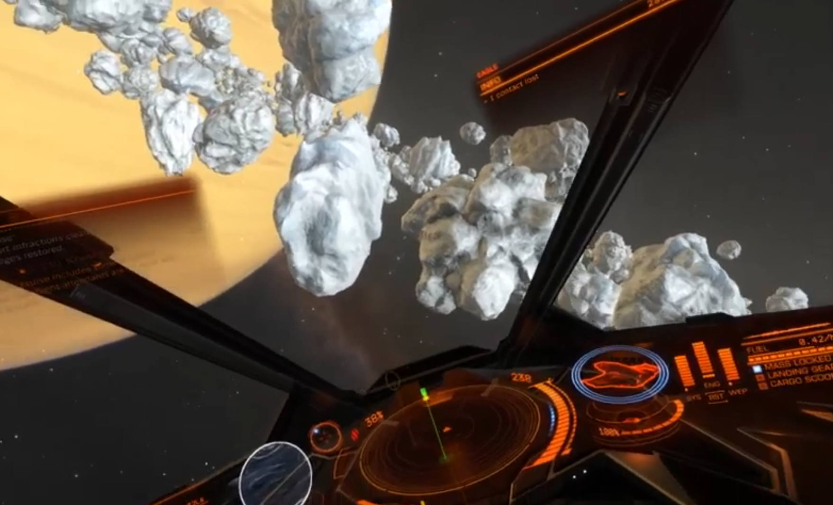

The interior of the ship in the image is similar to our concept for our ship as well. The console, UI, etc. will help reduce motion sickness that a user may experience. Rather than playing as the ship, we will be playing as the pilot within the ship. Our goal is be able to easily control the ship while playing as the pilot by grabbing or pressing controls as if the oculus controllers were hands. If it becomes too tedious or too difficult to perform these tasks to pilot our ship we will instead map controls directly to buttons on the controller and just play animations in the cockpit for corresponding control activations.

Group Members & Tasks
Name | Tasks
Viktor Fries | 3D Modeling of assets and interior cockpit design in the ship
Lukas Hoffman | Physics/collision scripting
Brandon Huzil | Enemy and asteroid pathing and general scripting
Jared Thompson | General scripting for game mechanics

Milestones
Milestone 1 | Interactive cockpit designed (switches can be pressed, levers can be pulled, etc)
Milestone 2 | Populated and moving environment (asteroids, other ships, etc) - MVP
Milestone 3 | Barebones combat implementation (Weapons that fire, take damage) – Vertical slice
Milestone 4 | Polishing, additional ships, variety, adding visual effects to better user’s immersion –Target
Milestone 5 | Additional game modes, objectives, or a multiplayer aspect – Stretch
Milestone 6 | Additional game modes, objectives or a multiplayer aspect – Stretch

Difficulty
Our project will provide a sufficient challenge for each member of the group. No one has experience with Unity, game design, or anything related to VR in general. We are all however taking the Creative technologies 310AD class this semester where we learn to develop in unity which will provide knowledge and skills which will aid us in this project. Viktor has prior experience with some modeling, but the others do not. In terms of C#, nobody has extensive experience coding/scripting in this language however we do have experience in similar languages such as C++ and Java.

